

POST AND TELECOMMUNICATIONS TECHNOLOGY
FACULTY OF INFORMATION TECHNOLOGY I

----------
REPORT
TEST 01 (17/09/2026)

Instructor: Tran Dinh Que
Student: Vu Dinh Hieu – B23DCCE036
Date of Birth: September 30, 2005
Class: E23TTNT02-B
Phone Number: 0868448269

Hanoi, 17/09

Câu 1:

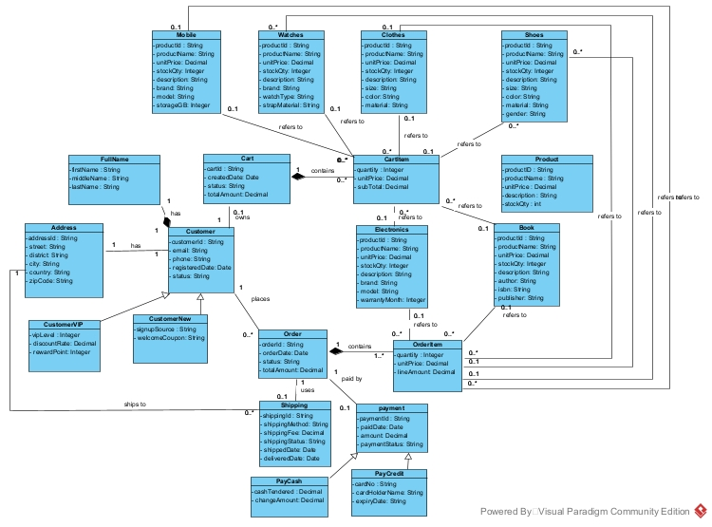

Câu 2:

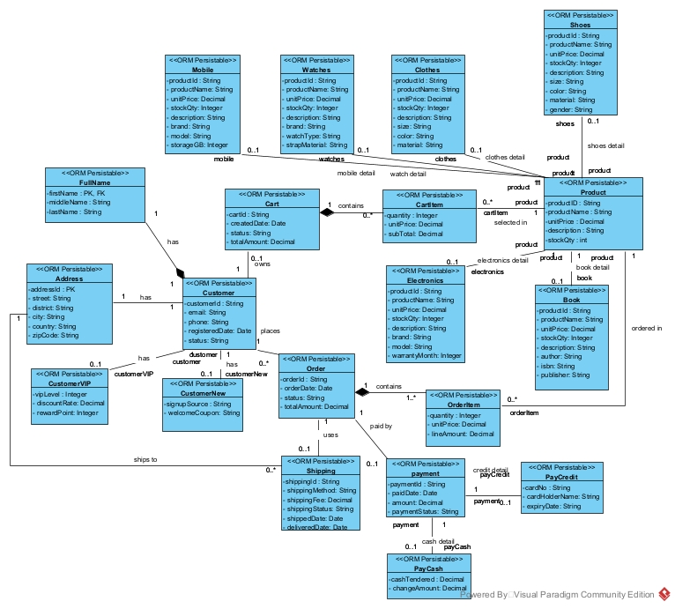

Data Modeling

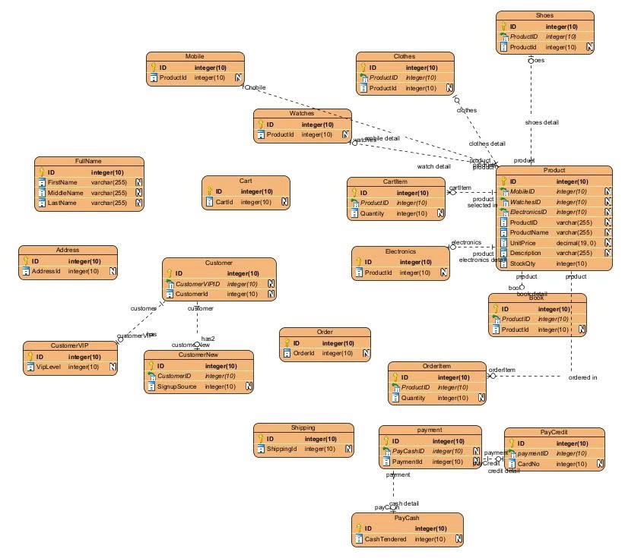
Cấu trúc thư mục
